A room with a large screen

Description generated with very high confidenceA display in a store

Description generated with high confidence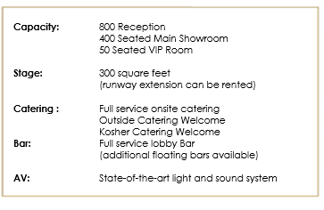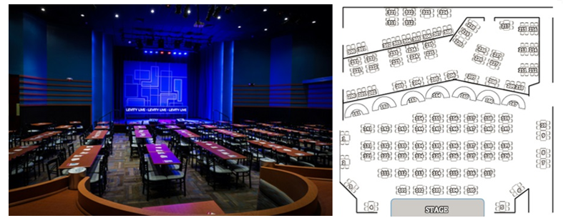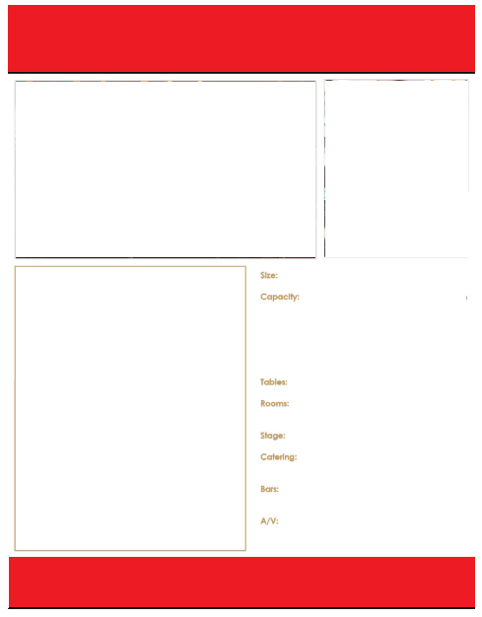

**Levity Live**

As part of the Improv family, we continue to build our iconic brand legacy and evolve the live experience for new audiences. Levity Live, located in West Nyack, NY

at the Palisades Center, is a 350-seat comedy club and entertainment venue with weekly performances by legendary comedians and a variety of entertainment.

Whether you are hosting an intimate gathering, meeting, or full venue buyout, Levity Live is the perfect event destination for any occasion.

Our versatile multi-use space includes a full-service bar and lounge, showroom with stage and state-of-the-art light and sound system, Green Room, digital marquee, box office, onsite event production, custom menus, preferred catering and talent booking.

Visit our website to view our schedule of events <https://nyack.levitylive.com/>

**READY TO BOOK YOUR NEXT EVENT:**

**contact:**

[jbergin@levitylive.com](mailto:jbergin@levitylive.com)

845-353-5400 x213

4210 Palisades Center Drive

West Nyack, NY 10994

845-353-5400

[www.nyack.levitylive.com](http://www.nyack.levitylive.com)